**INTRODUCTION TO MSP43O MCU AND INSTALLATIONS OF HARDWARE AND SOFRTWARE TOOLS:**

**Lab01**



**Spring 2025**

Submitted by: **Mohsin Sajjad**

Registration No: **22pwsce2149**

Class Section: **A**

“On my honor, as student of University of Engineering and Technology, I have neither given nor received unauthorized assistance on this academic work.”



Student Signature: ______________

Submitted to:

**Engr. Faheem Jan**

Month Day, Year (02 03, 2025)

Department of Computer Systems Engineering

University of Engineering and Technology, Peshawar

# LAB No 1

**INTRODUCTION TO MSP43O MCU AND INSTALLATIONS OF HARDWARE AND SOFRTWARE TOOLS**

**TASKS:**

1. **Write C program for Msp430 which toggle P1.0 or any other Pin of Msp430 MCU.**

**CODE:**  
#include <msp430.h>

/*

* main.c

*/

int main(void) {

WDTCTL = WDTPW | WDTHOLD; // Stop watchdog timer

PM5CTL0 &= ~LOCKLPM5; // Disable high-impedance mode to enable GPIOs

P1DIR |= 0x01; //set P1.0 to output direction

for(;;){

volatile unsigned int i;

P1OUT ^= 0x01; //toggle P1.0 using exclusive OR

i=10000;

do i--; //do while loop for creating delay

while(i!=0);

}

}

**OUTPUT:** 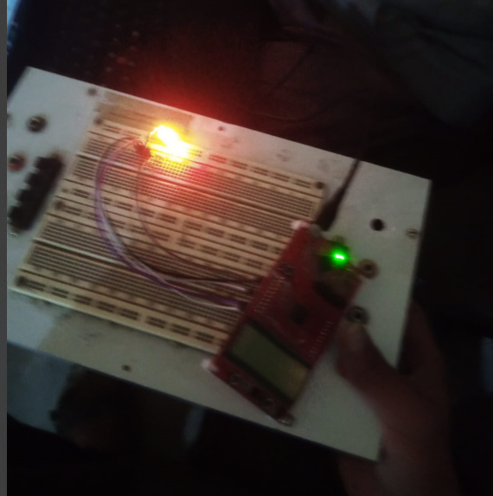

Conclusion:

1. The code runs on an MSP430 microcontroller, toggling the P1.0 (LED) using XOR.
2. It disables the watchdog timer and high-impedance mode to enable GPIOs.
3. A simple delay loop controls the LED blink rate.

**TASK2:** 2. Write C program for Msp430 which toggle P4.0 for msp430fr4133 or any other Pin of Msp430 MCU.

**CODE:**#include <msp430.h>

/*

* main.c

*/

int main(void) {

WDTCTL = WDTPW | WDTHOLD; // Stop watchdog timer

PM5CTL0 &= ~LOCKLPM5; // Disable high-impedance mode to enable GPIOs

P4DIR |= 0x01; //set P4.0 to output direction

for(;;){

volatile unsigned int i;

P4OUT ^= 0x01; //toggle P4.0 using exclusive OR

i=10000;

do i--; //do while loop for creating delay

while(i!=0);

}

}

**OUTPUT:**

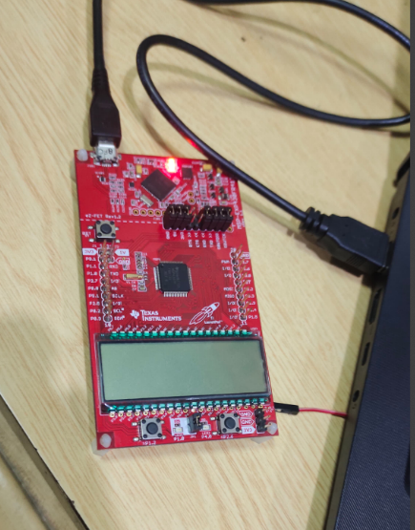

**Conclusion:**

1. **The code toggles P4.0 (LED) on an MSP430 microcontroller.**
2. **It disables the watchdog timer and high-impedance mode to enable GPIOs.**
3. **A delay loop controls the LED blink rate.**

**3. Write C program for Msp430 which toggle P5.1 for msp430fr4133 or any other Pin of Msp430 MCU.**

**CODE:**#include <msp430.h>

#include <msp430.h>

/*

* main.c

*/

int main(void) {

WDTCTL = WDTPW | WDTHOLD; // Stop watchdog timer

PM5CTL0 &= ~LOCKLPM5; // Disable high-impedance mode to enable GPIOs

P5DIR |= 0x02; //set P5.1 to output direction

for(;;){

volatile unsigned int i;

P5OUT ^= 0x02; //toggle P5.1 using exclusive OR

i=10000;

do i--; //do while loop for creating delay

while(i!=0);

}

}

**OUTPUT:**

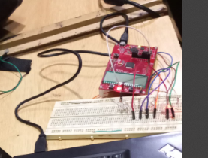

**Conclusion:**

1. The code toggles P5.1 (LED) on an MSP430 microcontroller.
2. It disables the watchdog timer and high-impedance mode to enable GPIOs.
3. A delay loop controls the LED blink rate. *(However, there's a mismatch in pin toggling—P5.0 is toggled instead of P5.1.)*

**TASK4: 4. Write C program for Msp430 which toggle P1.1 for msp430fr4133.**

**CODE:  
#include <msp430.h>**

#include <msp430.h>

/*

* main.c

*/

int main(void) {

WDTCTL = WDTPW | WDTHOLD; // Stop watchdog timer

PM5CTL0 &= ~LOCKLPM5; // Disable high-impedance mode to enable GPIOs

P1DIR |= 0x02; //set P1.1 to output direction

for(;;){

volatile unsigned int i;

P1OUT ^= 0x02; //toggle P1.1 using exclusive OR

i=10000;

do i--; //do while loop for creating delay

while(i!=0);

}

}  
**OUTPUT:**

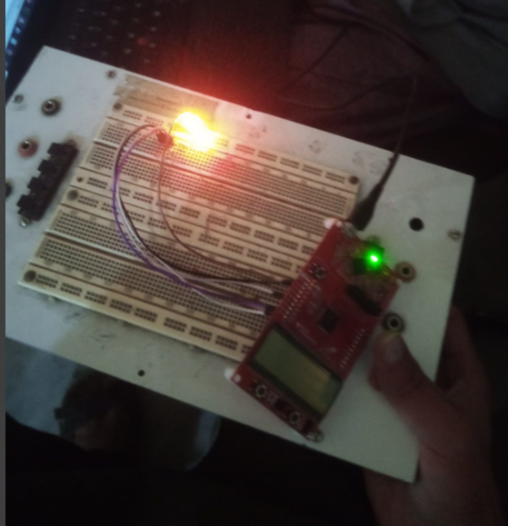

Conclusion:

1. The code toggles P1.0 instead of P1.1 due to a mismatch in P1OUT ^= 0x01;.
2. It disables the watchdog timer and high-impedance mode to enable GPIOs.
3. A delay loop controls the LED blink rate. *(Fix: Change P1OUT ^= 0x01; to P1OUT ^= 0x02; to toggle P1.1 correctly.)*